NAME : KRISHNAKUMAR.R ROLL NO : 240701275

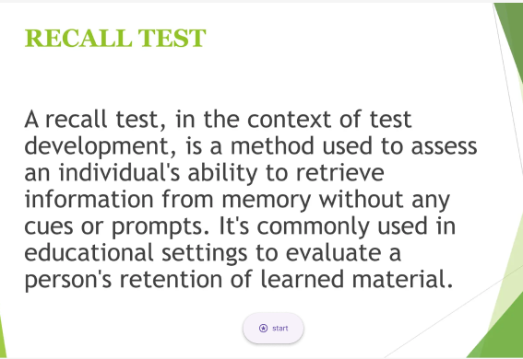

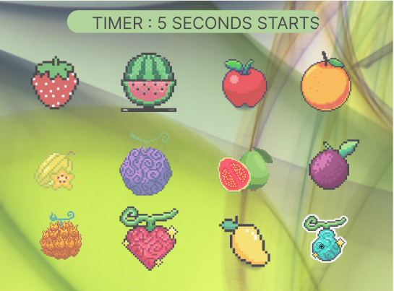

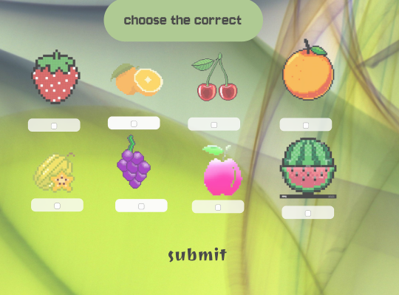

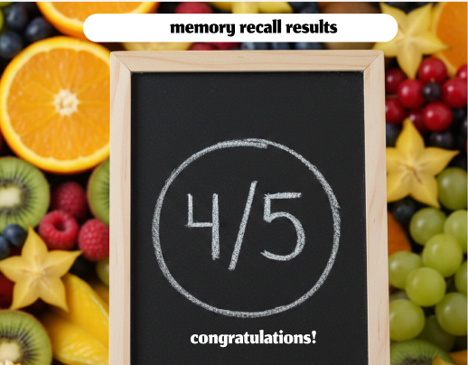

Experiment: Recall Test Web Application

Aim
To design and develop a simple Recall Test web application using HTML, CSS, and basic scripting to evaluate a user's ability to remember and retrieve information without prompts.

Objective
- To understand the concept of memory recall testing.
- To create an interactive webpage that starts a recall test.
- To learn web interface design and basic user interaction.

Tools / Technologies Used
- HTML – to create the structure of the webpage
- CSS – to style the interface and layout
- JavaScript (optional) – to control the start button and test flow
- Web Browser – to run and test the application

Procedure
- Create an HTML file for the Recall Test webpage.
- Add a title “RECALL TEST” at the top of the page.
- Write a description explaining what a recall test is and its purpose.
- Use CSS styling to design the background, text color, and layout for a clean interface.
- Place a “Start” button at the bottom of the description.
- When the user clicks the Start button, the recall test process begins (for example: showing words, numbers, or images to remember).
- After a short time, the user is asked to recall or type the information they remember.
- The program then checks the responses and evaluates memory performance.
Result
The Recall Test webpage was successfully created. The interface explains the concept of recall testing and allows the user to begin the test using a Start button.

Conclusion
This experiment demonstrates how web technologies can be used to build simple cognitive testing tools. It also helps in understanding memory assessment techniques and interactive web design.

LINK:

https://www.figma.com/design/Fu5HXSYimb5rD39ZjU3hsT/Untitled?t=2cNOekUFy3Ds85JZ-1

